PBIO 504 Fall 2019 Name: Michael Chambers

t-tests

Reading Assignment Chapters 9.3 and 11 from the textbook

Homework Instructions

Data Set A: Zinc Concentration (see worksheet)

Data Set B: Oat bran cereal
A crossover study was conducted to investigate whether oat bran cereal helps to lower serum cholesterol levels in hypercholesterolemic males. Fourteen such individuals were randomly placed on a diet that included either oat bran or com flakes; after two weeks, their low-density lipoprotein (LDL) cholesterol levels were recorded. Everyone was then switched to the alternative diet. After a second two-week period, the LDL cholesterol level of each individual was again recorded. The data from this study are shown below.
 | LDL(mmol/l)
subject | Corn flakes | Oat Bran
1 | 4.79 | 3.18
2 | 5.09 | 3.59
3 | 5.72 | 4.19
4 | 4.35 | 3.38
5 | 4.63 | 6.21
6 | 6.85 | 3.79
7 | 4.86 | 2.79
8 | 4.62 | 3.93
9 | 3.14 | 3.01
10 | 4.44 | 4.25
11 | 4.23 | 4.33
12 | 4.43 | 4.46
13 | 3.88 | 2.36
14 | 3.77 | 4.31
15 | 3.74 | 4.41
16 | 4.23 | 2.57
17 | 5.77 | 5.09
18 | 5.46 | 4.91
19 | 4.09 | 6.52
20 | 2.8 | 4.25

Data Set C: Low birth weight

The data set lowbwt contains information for a sample of 100 low birth weight infants
born in two teaching hospitals in Boston, Massachusetts. Measurements of systolic blood pressure are saved under the variable name sbp and indicators of gender-with 1 representing a male and 0 a female. Import the Excel File containing the data. Construct the histogram of systolic blood pressure to check the assumption. You will use the function ttest in STATA. Answer the questions on the worksheet.

HOMEWORK WORKSHEET: T-Tests

NOTE: Always include information about null hypothesis, alternative hypothesis, testing result as well as your interpretation. Show your work.

PART A – Zinc Concentration

Trace metals in drinking water affect the flavor and an unusually high concentration can pose a health hazard. Ten pairs of samples were taken measuring zinc concentration in bottom water and surface water. The data are shown below. Import the Excel File (water) into Stata.

 | Location
 | 1 | 2 | 3 | 4 | 5 | 6 | 7 | 8 | 9 | 10
Zinc  concentration in  bottom water | .430 | .266 | .567 | .531 | .707 | .716 | .651 | .589 | .469 | .723
Zinc  concentration in  surface water | .415 | .238 | .390 | .410 | .605 | .609 | .632 | .523 | .411 | .612
- State the hypotheses.

H_{O} – The difference in mean zinc concentration between the surface and bottom of the water is zero (there is no difference), μ_{surface [zinc]} = μ_{bottom [zinc]}
H_{A} – The difference in mean zinc concentration between the surface and bottom of the water is NOT zero (there is a difference), μ_{surface [zinc]} ≠ μ_{bottom [zinc]}

- Perform the paired t-test and interpret the results.

Paired T-statistic: 4.8638
P-value: 0.0008

Based on these results I would reject the null hypothesis in that there is a difference in zinc concentrations between the surface and bottom of the water, with higher concentrations of zinc at the bottom of the water.

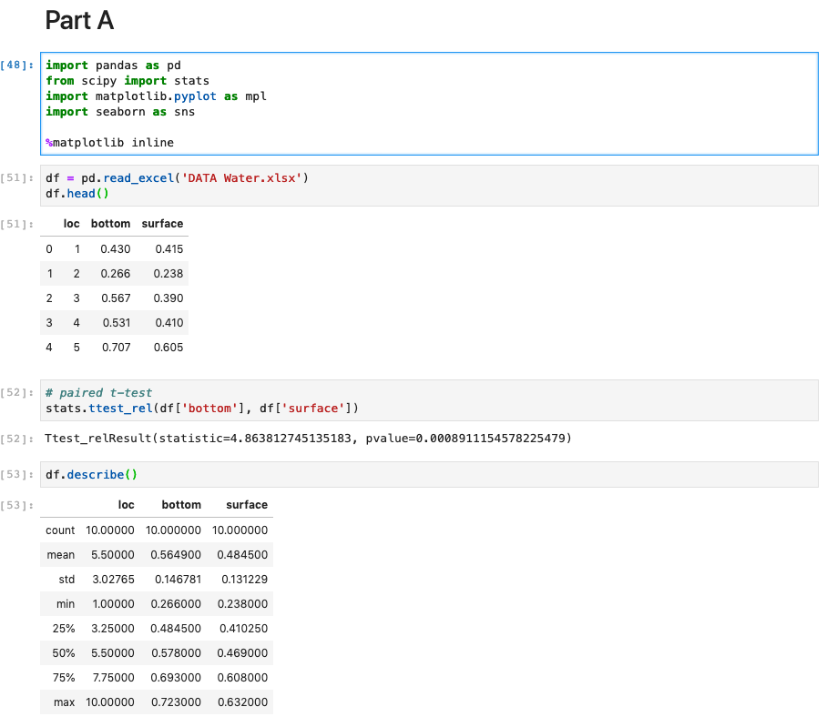

PART B - Oat bran cereal

(3) Are the two samples of data paired or independent?

Paired Samples of Data – every subject observed in the first group is also observed in the second group (individuals serve as their own controls)

(4) What are the appropriate null and alternative hypotheses for a two-sided t-test?

H_{O} – The mean LDL of the difference between the Corn Flakes and Oat Bran conditions is 0 (no difference)
H_{A} – The mean LDL of the difference between the Corn Flakes and Oat Bran conditions is NOT 0 (there is a difference)

(5) Conduct the test at the 0.05 level of significance. What is the t statistic and p-value?

T-statistic: 1.5419
P-value: 0.1396

(6) What do you conclude based on the results?

The null hypothesis is not rejected, based on this sampling data there is no significant difference in the mean LDL between the two experimental conditions.

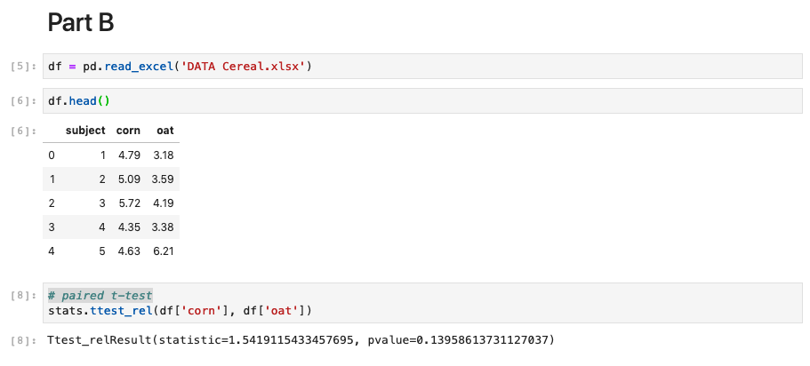

PART C - Low birth weight

(7) Construct a histogram of systolic blood pressure measurements by gender.
Based on the graphs, do you believe that blood pressure is approximately normally distributed in each group?

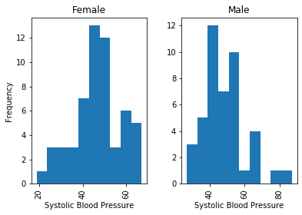
Based on the graphs, I do believe that the systolic blood pressure is approximately normally distributed for each group, though there may be a bit of a right shoulder for the female sbp distribution and a trailing off on the right for the male sbp distribution.

(8) Construct boxplots of systolic blood pressure measurements separated by gender, describe your observations on the systolic blood pressure distributions in these two gender groups based on the boxplots.

The systolic blood pressures (sbp) distrubutions in these two gender groups appear to share a mean value as well as similar Q1 and Q3 values, though the female values appear to be more tightly grouped than the male values.

(9) State the null hypothesis that among low birth weight infants, the mean systolic blood pressure for boys and girls is the same. Use a two-sided test at the 0.05 level of significance. What do you conclude?

H_{O} – Among low birth weight infants, the mean difference in systolic blood pressure between males and females is zero (no difference between the two groups),
μ_{sbp males} = μ_{sbp females}
H_{A} - Among low birth weight infants, the mean difference in systolic blood pressure between males and females is NOT zero (there is a difference between the two groups),
μ_{sbp males} ≠ μ_{sbp females}

Two-sided t-statistic: 0.6072
P-value: .5451

I conclude that based on this sample data the null hypothesis is not rejected, among low birth weight infants there is no significant difference between the mean systolic blood pressure values.

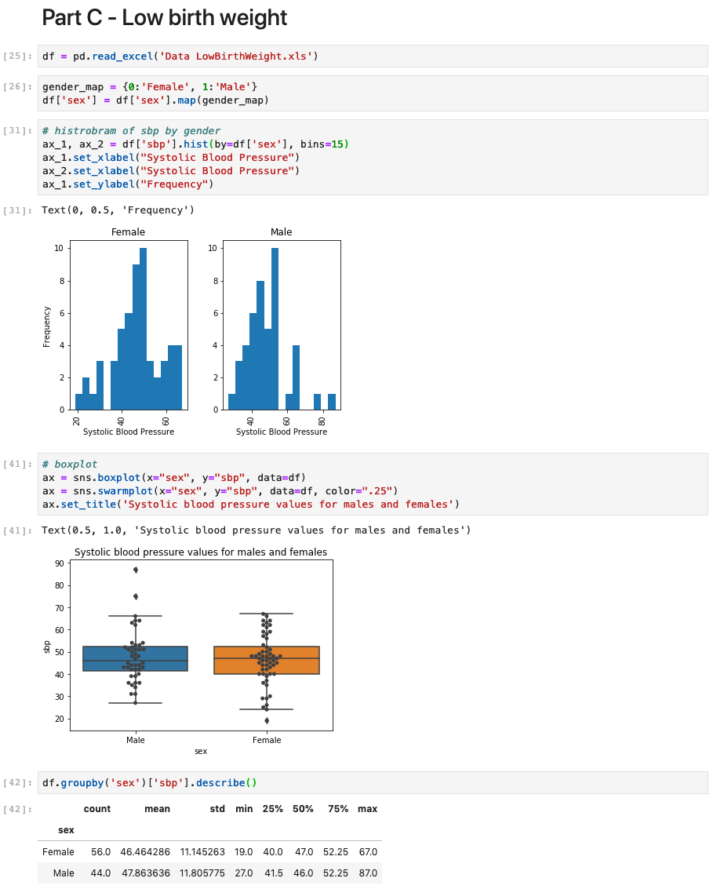
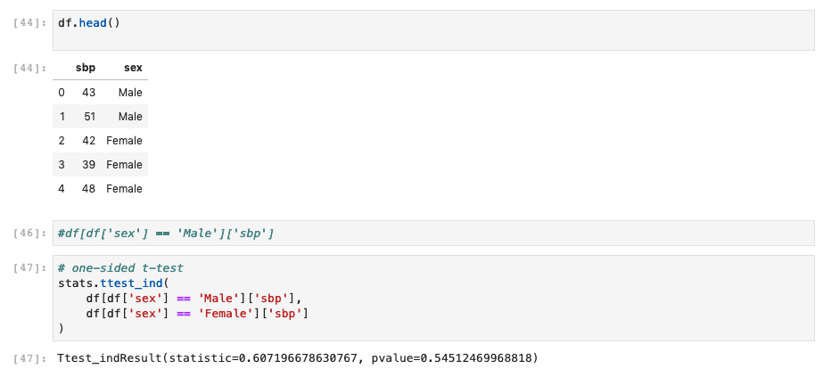

LESSONS LEARNED

(10) What is the major difference between the two sample T-test and the paired T-test? When should we use one versus the other?

A test statistic is a formula that allows us to preform a test between sample groups. The t-test is used to compare means from two different groups

The two-sample T-test does not share individuals between the two groups, values from individuals are attained once.

In contrast, the application of a paired T-test requires paired samples. This means that each subject is observed in both groups, which reduces the variability in the study as each subject acts as their own control. In such a study, the measure of interest is the difference in the means between the two groups.

